**Jenkins Task- 4 Date : 29-08-2024**

**1) Setup jenkins CICD pipeline using freestyle job using below code.** [**https://github.com/betawins/hiring-app.git**](https://github.com/betawins/hiring-app.git)

**Stages: 1) Git Clone**

**2) Sonarqube Integration**

**3) Maven Compilation**

**4) Nexus Artifactory**

**5) Slack Notification**

**6) Deploy On tomcat**

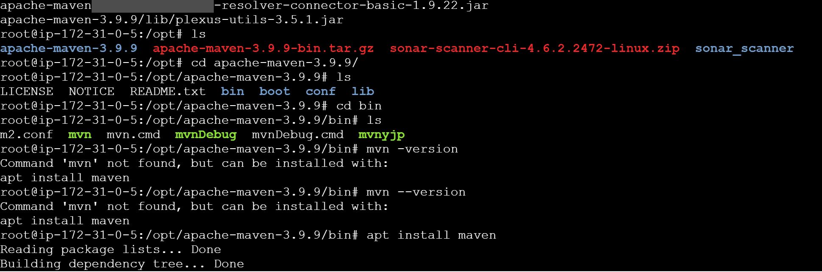

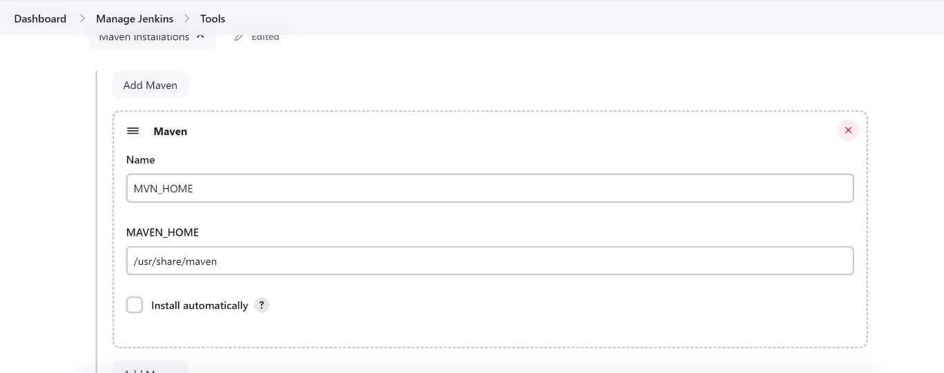

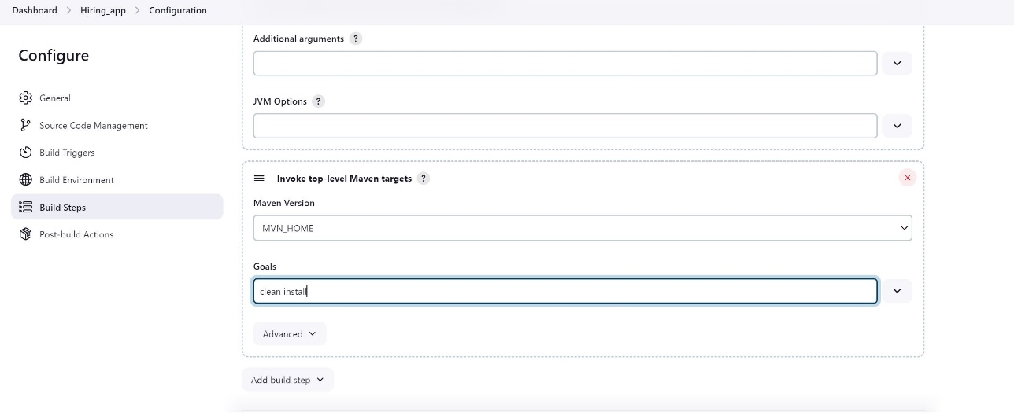

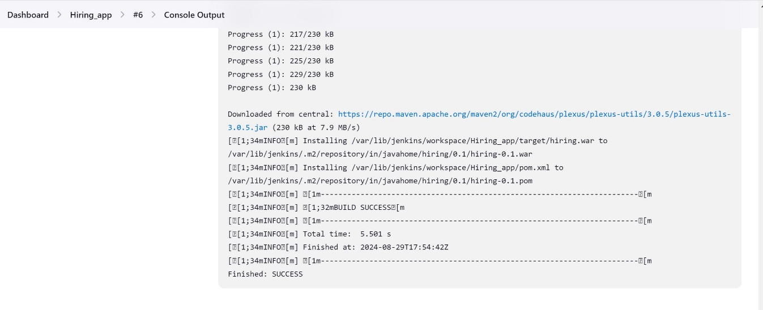

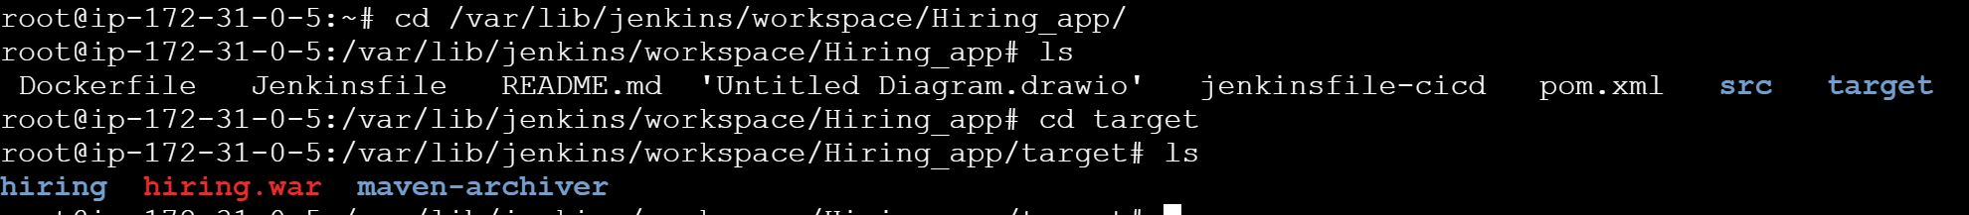

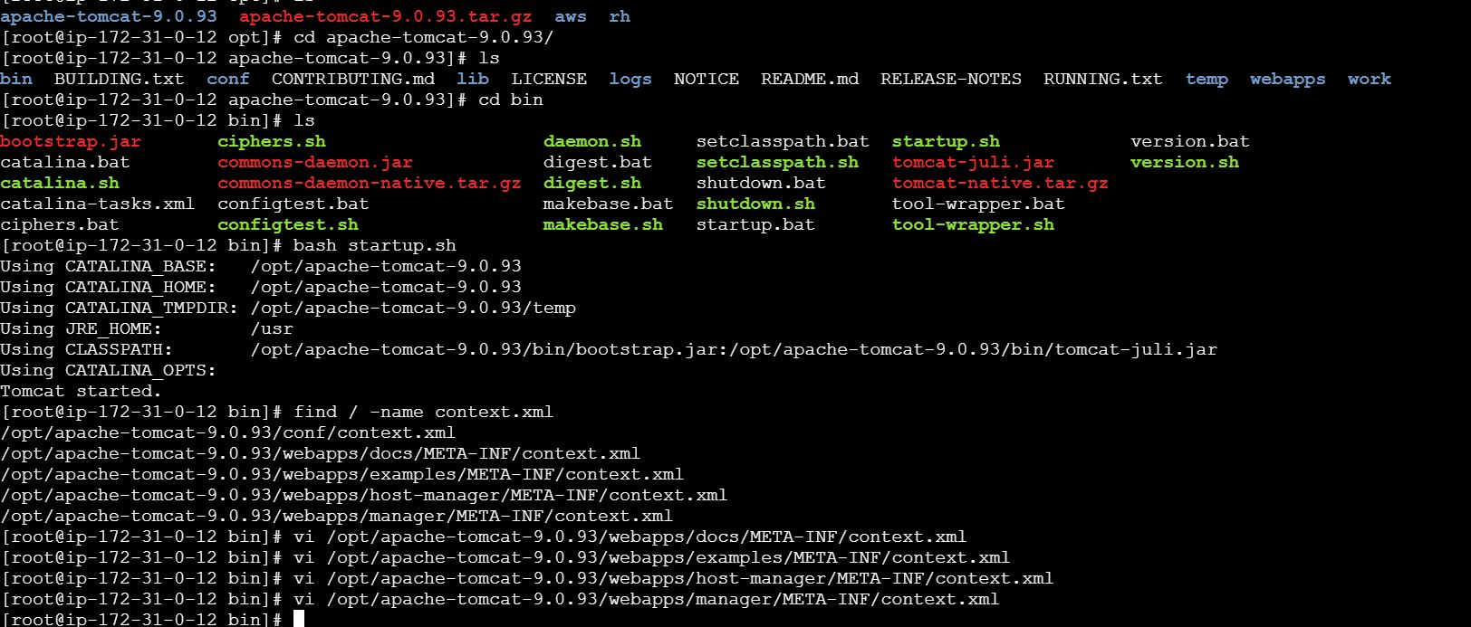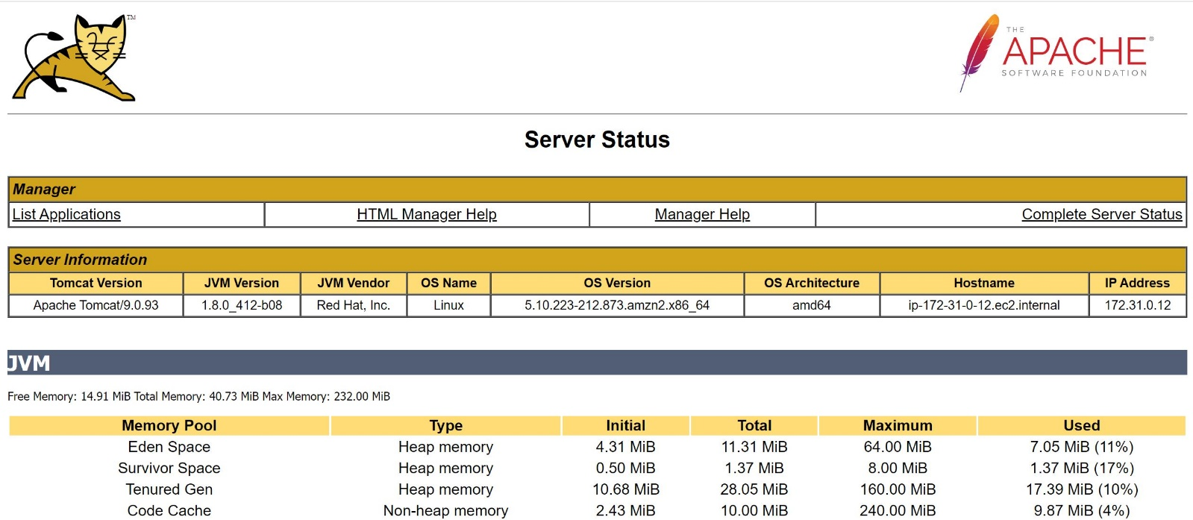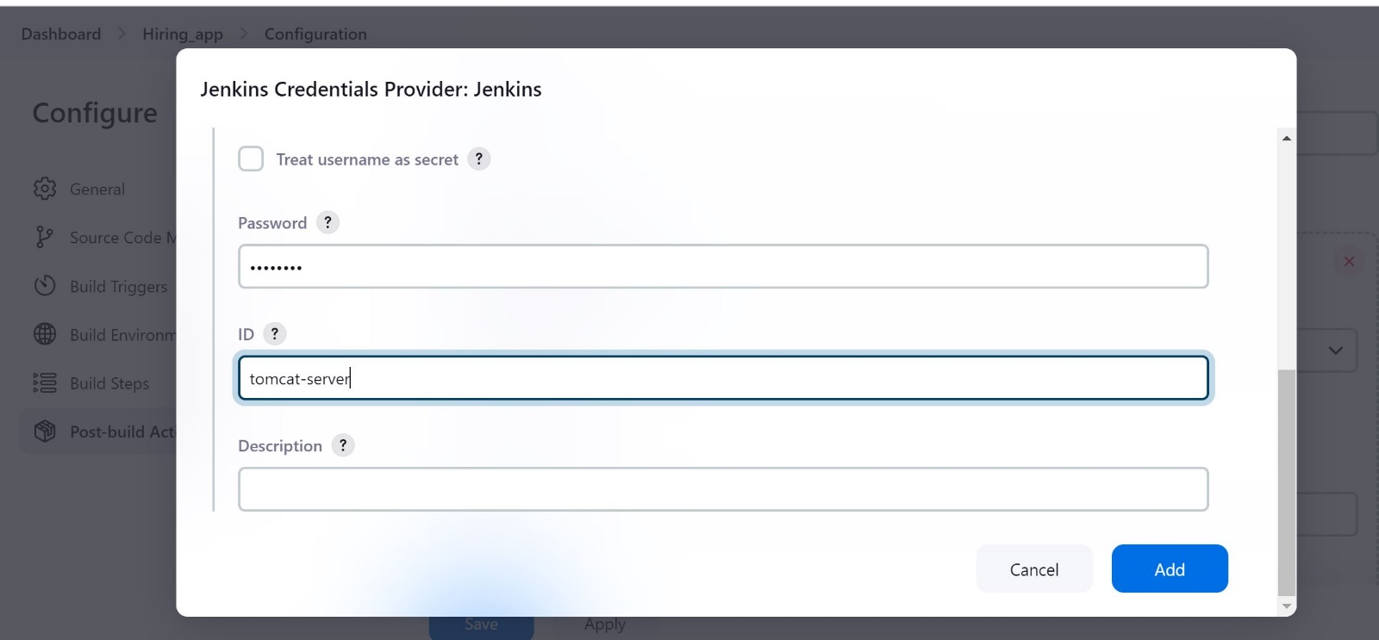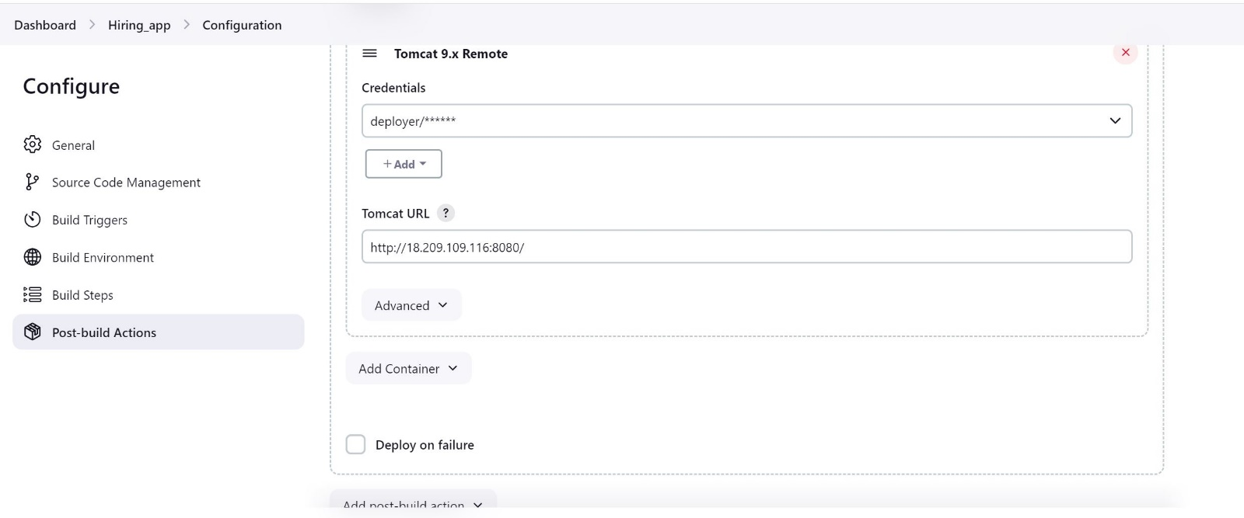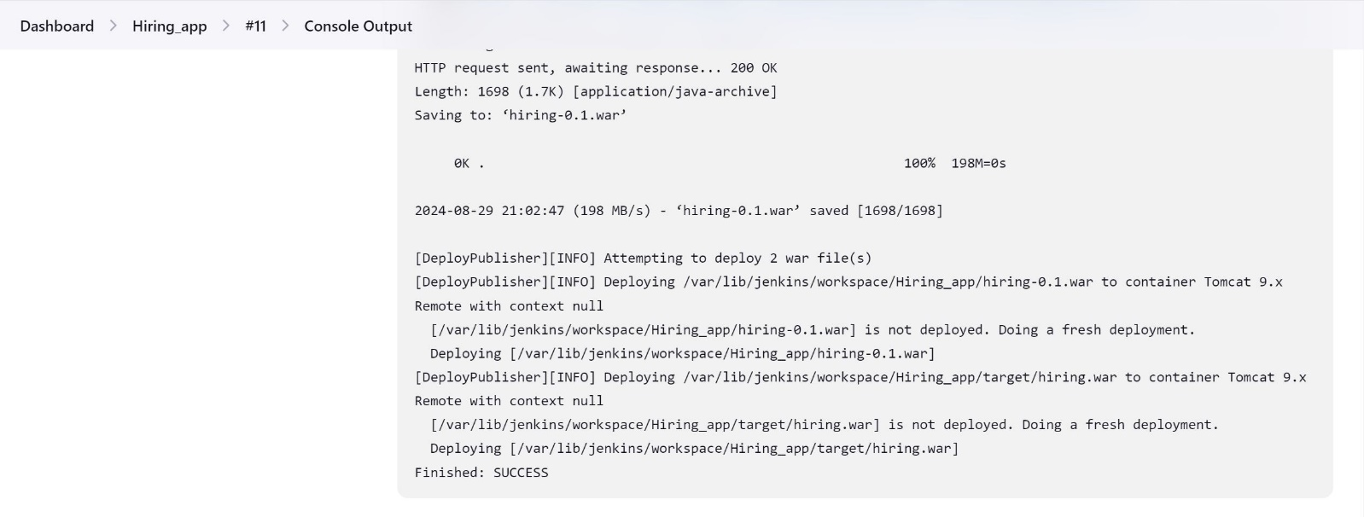

**2) Setup jenkins job using freestyle job using below code.** [**https://github.com/betawins/Techie_horizon_Login_app.git**](https://github.com/betawins/Techie_horizon_Login_app.git) **Stages:**

**1) Git Clone**

**2) Sonarqube Integration**

**3) Maven Compilation**

**4) Nexus Artifactory**

**5) Slack Notification**

**6) Deploy On tomcat**

